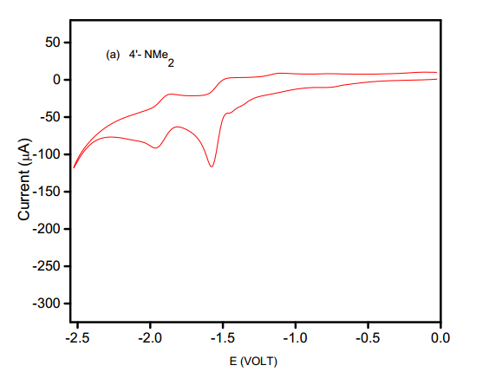

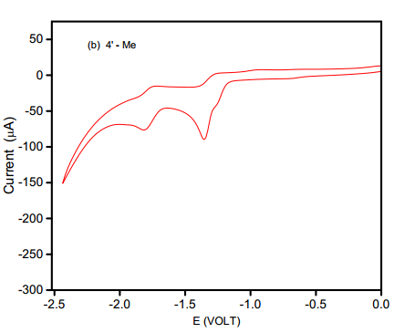

Fig. Cyclic voltammograms for (a) (E)-1-(furan-2-yl)-3-(4’-N,N-dimethylaminophenyl)-prop-

2-ene-1-ones and (b) (E)-1-(furan-2-yl)-3-(4’-methylaminophenyl)-prop-2-ene-1-ones in tetra

butyl ammonium tetra fluoroborate.

Solvent = acetonitrile; working electrode = glassy carbon; Sweep rate = 40 mv/s

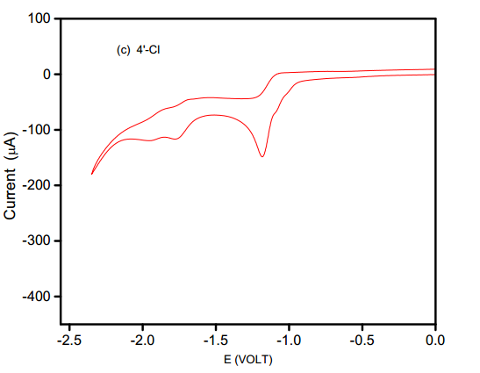

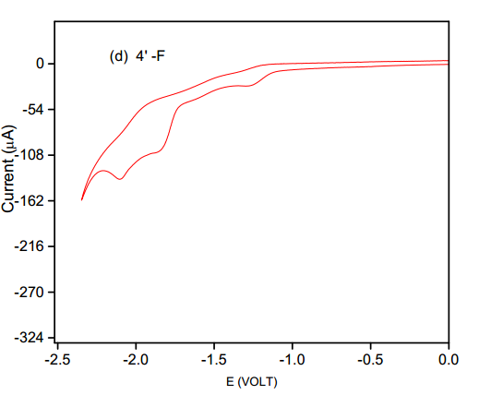

Fig. Cyclic voltammograms for (a) (E)-1-(furan-2-yl)-3-(4’-chlorophenyl)-prop-

2-ene-1-ones and (b) (E)-1-(furan-2-yl)-3-(4’-flurophenyl)-prop-2-ene-1-ones in tetra

butyl ammonium tetra fluoroborate.

Solvent = acetonitrile; working electrode = glassy carbon; Sweep rate = 40 mv/s

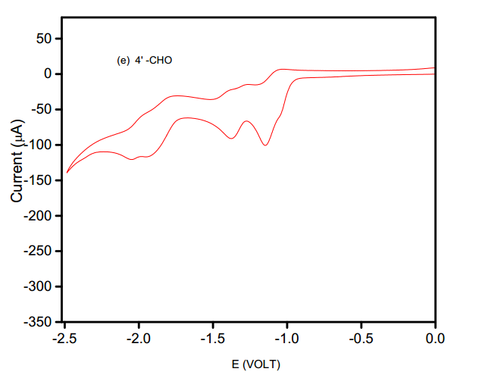

Fig. Cyclic voltammograms for (a) (E)-1-(furan-2-yl)-3-(4’-phenyl)-prop-

2-ene-1-ones in tetrabutyl ammonium tetra fluoroborate.

Solvent = acetonitrile; working electrode = glassy carbon; Sweep rate = 40 mv/s